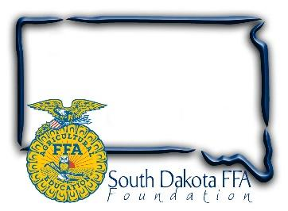

**For Immediate Release**

Contact: Gerri Ann Eide

605-765-4865

Gerri@sdffafoundation.org

***FFA members package 55,728 meals during Living to Serve Day***

(Bath, SD) – April 9, 2025 – The blue corduroy jacket is a familiar symbol of the FFAorganization, worn as part of official dress during most FFA activities. On April 3rd at the South Dakota FFA convention in Brookings, as part of a SD FFA Living to Serve Day, members removed their jackets androlled up their sleeves to help stop hunger in South Dakota.

Working with industry and Meals of Hope, this South Dakota FFA Foundation hands-on project combats hunger.  SD FFA members measured, poured, sealed, and boxed 55,728 meals in assembly line fashion. Members stopped in between workshops and competitive events throughout convention and left the event knowing that by giving a few minutes of their time they would make a significant difference in the life of a person less fortunate than themselves.

    The Meals of Hope food packages are a hearty Chicken flavored Rice & Vegetable Soup meal.  All of the 55,728 meals were donated to Feeding South Dakota based in Sioux Falls and the Feeding Brookings food pantry these meals will be distributed across our state, Jennifer Stensaas, Community Engagement Manager for Feeding South Dakota attended and expressed great appreciation for the event, the members' hard work, and SD FFA’s food donation. In addition, when asked how long the supply might last, Jennifer stated that during high need times it may only last 30-60 days.

      Sandy Osterday, SD FFA Foundation board president and event chairman added, “The South Dakota FFA and FFA Foundation are proud to be able to have a part in providing quality food to families in need across our state. We are grateful for our sponsors who believe in our mission of Living to Serve. “

The South Dakota FFA Foundation received event funding through grants provided by Global Harvest Foods, Beck’s Hybrids, Farmhouse Fraternity – SDSU, and Corteva Agriscience’s, Pioneer seed team, who also provided area staff that were great hands-on help during the event.

The SD FFA Foundation supports Agricultural Education and the FFA's mission to make a difference in the lives of students by developing their potential for premier leadership, personal growth and career success through agricultural education. For more information about the South Dakota FFA Foundation and South Dakota's FFA programs, visit [www.sdffafoundation.org](http://www.sdffafoundation.org/) or follow us on Facebook.

Photos: FFA members from across the state work together to measure, package and seal meals during the Day of Service, Meals of Hope Project at State FFA Convention.

#   #   #